**Cloud Computing: UE20CS352**

**Experiment 5**

**-Adithya M, Section K**

**-PES1UG20CS621**

**● user-1 added to the S3-Support Group.**

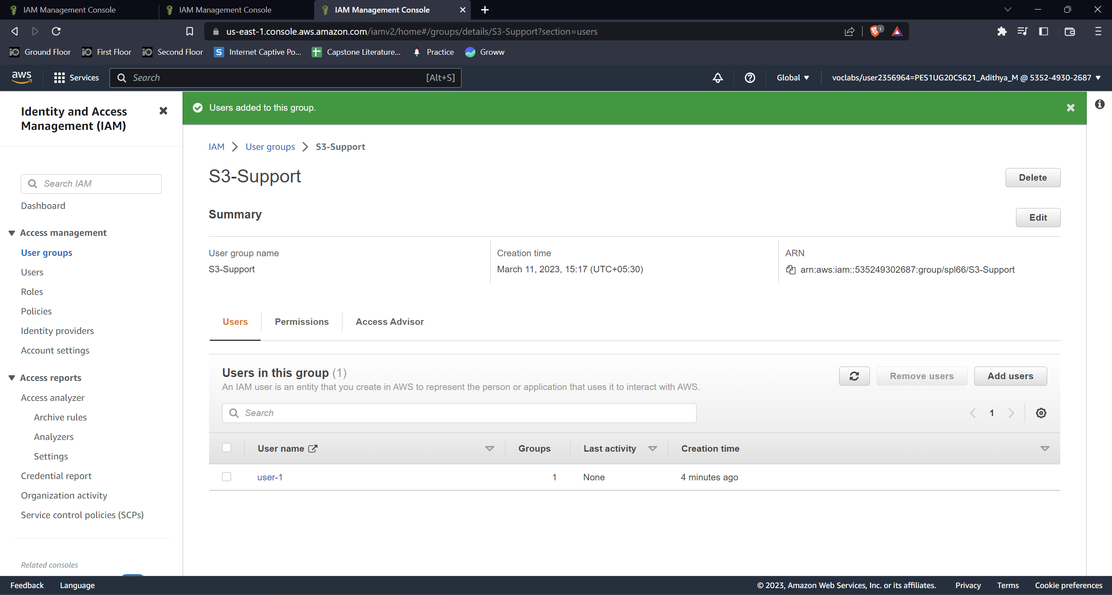

**● user-2 added to the EC2-Support Group.**

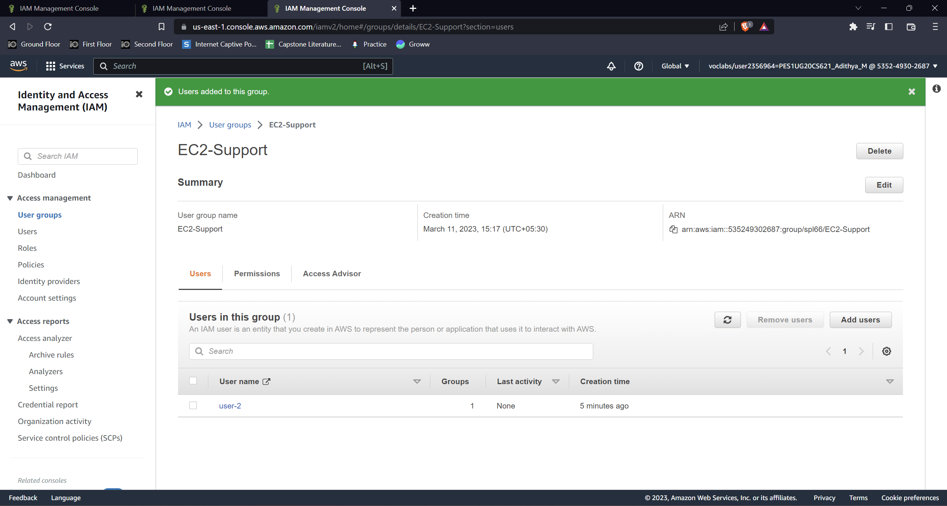

**● user-3 added to the EC2-Admin Group.**

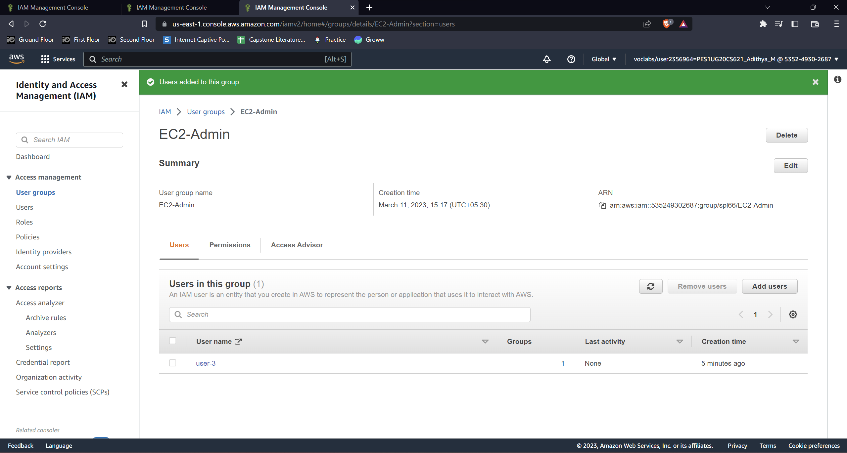

**● View S3 buckets with user-1 role**

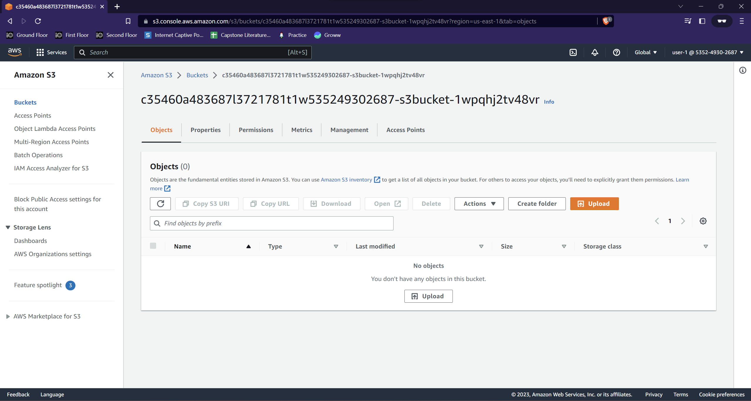

**● EC2 instance dashboard with user-1 role (Not authorized)**

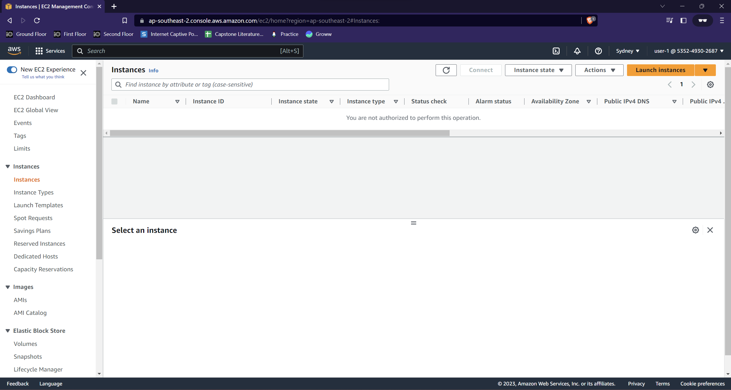

**● Failure message when instance stopped with user-2 role**

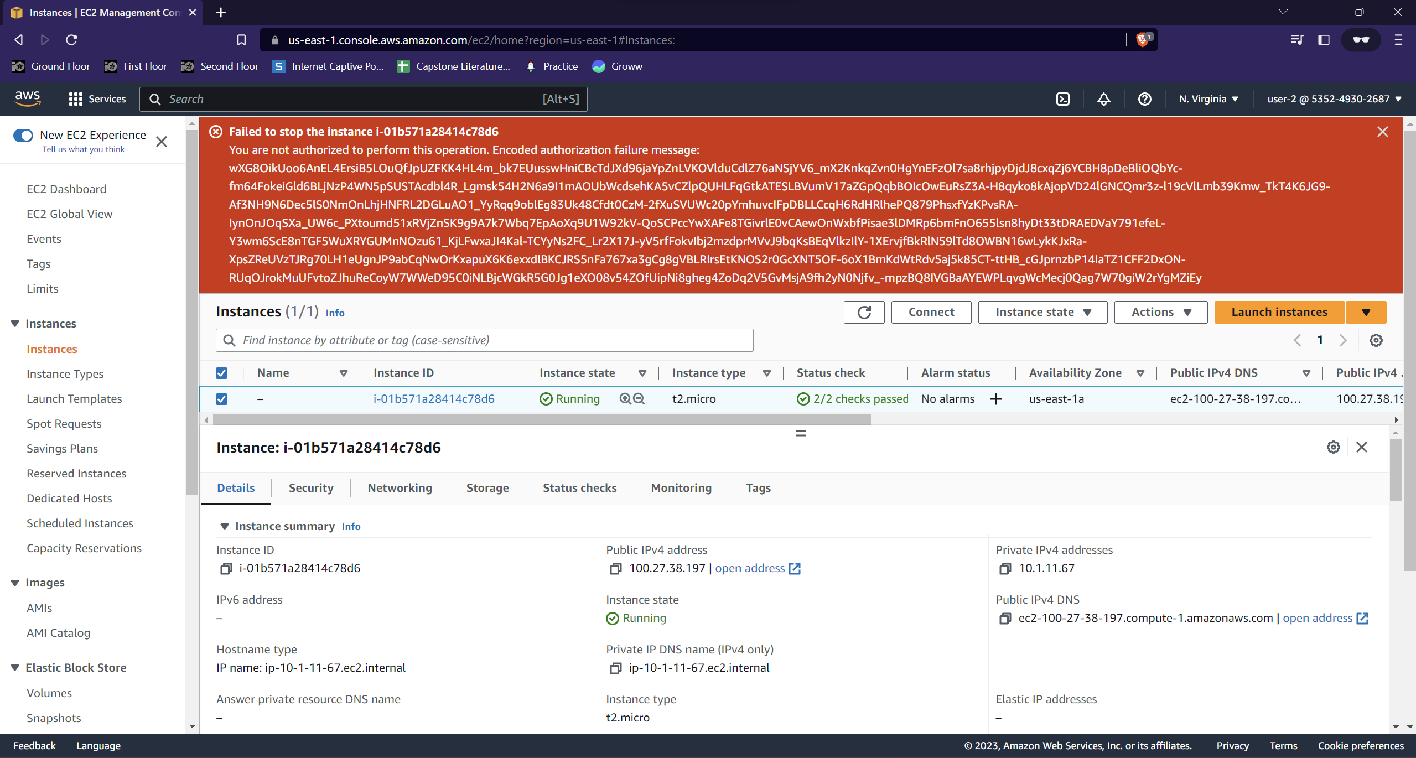

**● Successful stoppage of E2 instance with user-3 role**